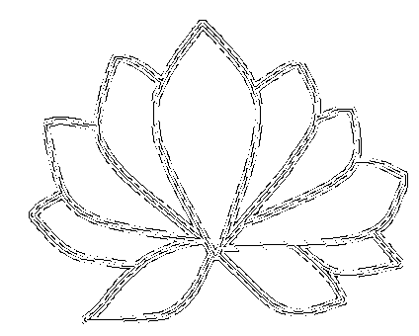
Firma Medical center Jarošová, s.r.o., IČO:05359856 Jaselská 1277/2, Říčany 25101

Ceník kapek GUNA:

500,- Kč: GUNA Arthro, Awareness, Bowel, Cell, Dermo, Fem, Flam, Lympho, Male, Matrix, Mood, Mycox, Osteobios, Digest, BDNF

550,- Kč: GUNA Diur, Dizzy, Hypertension, Prostate, Reflux, Sleep, Citomix

600,- Kč: GUNA Beta Endorfin, FSH, Geriatrix, Interferon alfa – INF, Interferon gama, Interleukiny všechny, Kidney, LH, Melatonin, NGF, NT3, NT4, Progesteron, T3, T4, TGF beta, TNF , TSH

680,- Kč: GUNA Liver, Rerio, Stomach, Virus

730,-Kč: Enervin, Epavin, Colestvin, Tirovin
850,-Kč: DMG FEX

Platnost a účinnost ceníku od 1.10.2024

Praha, 30.9.2024 Mgr. Hana Fechtnerová

